
RAMAIAH
Institute of Technology
USN | 1 | M | S

(Autonomous Institute, Affiliated to VTU)
(Approved by AICTE, New Delhi & Govt. of Karnataka) Accredited by NBA & NAAC with ‘A’ Grade

SEMESTER END EXAMINATIONS – JUNE 2019

Course & Branch | : | B.E. : Electrical and Electronics Engineering | Semester | : | IV
Subject | : | Signals and Systems | Max. Marks | : | 100
Subject Code | : | EE43/EE403 | Duration | : | 3 Hrs

Instructions to the Candidates:
- Answer one full question from each unit.

 |  | UNIT -I
1. | a) | Check the periodicity of the signals: | CO1 | (06)
 | b) | Determine whether the systems u(n) are Linear, time invariant, Causal, Memory less and stable. | CO1 | (08)
 | c) | Sketch the signal where r(t) is unit ramp signal. | CO1 | (06)
2. | a) | The output signal y(n) of a discrete time system is related to its input signal x(n) as follows. . Let the operator S denote a system that shifts its input by one unit. Formulate the operator H for the system relating y(n) to x(n). | CO1 | (06)
 | b) | Define power and energy signals. Determine whether the signal shown in the Fig. 2(b) is a power signal or energy signal. Justify your answer and further determine its energy or power.  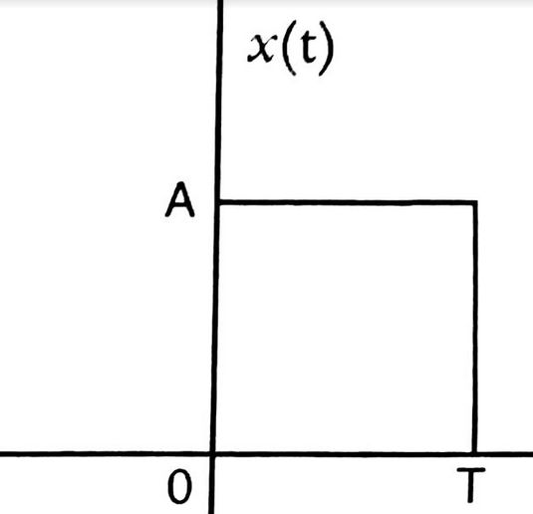  Fig.2(b) | CO1 | (06)
 | c) | Find the even and odd components of the signal x(n). Also plot  x(n-2) + x(n+3). Given  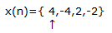 | CO1 | (08)
 |  | UNIT- II
3. | a) | Given x(t)= 2δ(t+1)+ δ(t-5) and h(t)=u(t-1). Obtain and plot the convolution integral graphically. | CO2 | (10)
 | b) | Evaluate the convolution y(n) for the signals h(n)=u(n)-u(n-3) and x(n)=δ(n)-2 δ(n-1)+ δ(n-2). | CO2 | (10)
4. | a) | Convolute graphically x(t)& h(t) given in Fig.4(a) and hence plot the output signal.  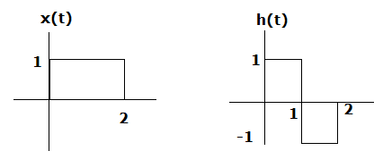  Fig.4(a) | CO2 | (10)
 | b) | Determine and plot the response of the LTI system whose input x(n) and impulse response h(n)are given by x(n)=u(n)- u(n-4) and h(n)=2^{n}{u(n)-u(n-5)}. | CO2 | (10)
 |  | UNIT- III
5. | a) | Define natural and force response of an LTI system. Find the complete response of the system given by the differential equation: | CO3 | (10)
 | b) | Obtain the direct form-I and form-II implementation of the system: y(n) - (1/2 )y (n-1) +(1/6 ) y(n-2) = x(n) + 2x(n-2). | CO3 | (10)
6. | a) | Determine the response of the first order discrete time system governed by the difference equation: | CO3 | (08)
 | b) | Find the natural response, forced response and complete response of the system given by the differential equation: | CO3 | (12)
 |  | UNIT- IV
7. | a) | Using convolution theorem , find the inverse DTFT of  X(e^{jΩ})= 1 / (1- a e^{-jΩ} )², |a|<1. | CO5 | (10)
 | b) | State and prove the following properties of DTFS:  - Frequency shift ii) Parseval’s property. | CO5 | (10)
8. | a) | Determine the:  - Fourier coefficients for the periodic sequence shown in fig. 8(a)  - Verify Parseval’s identity.  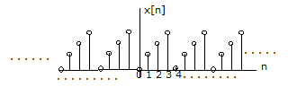  Fig.8(a) Periodic sequence (ramp function) | CO4 | (10)
 | b) | State and explain the following properties of DTFT:  - Convolution  - Time shift.  - Frequency Shift  - Modulation. | CO4 | (10)
 |  | UNIT- V
9. | a) | Find the Z transform and ROC of  i) x(n)=(-1)^{n} 2^{-n} u(n) ii) x(n)= [4 (3)^{n} -3(5)^{n}]u(n). | CO5 | (08)
 | b) | Find the impulse response of the system described by the difference equation: | CO5 | (12)
10. | a) | Using Z transform determine the response of LTI system with impulse response h(n)=0.4^{n} u(n), for an input x(n)= 0.2^{n} u(n). | CO5 | (10)
 | b) | List the properties of ROC. Also explain the time shifting and convolution properties of Z-transform. | CO5 | (10)

****************

